*Florida International University*

*School of Computing and Information Sciences*

Software Engineering Focus

Feature Document

User Story ID #648

**Name:** Mario Fidalgo

**Team Member(s):** Kyle Ryan

**Project:** Mobile Judge 9.0

**Product Owner(s)**: Masoud Sadjadi

**Mentor(s)**: Masoud Sadjadi

**Instructor**: Masoud Sadjadi

**User Story Name: Allow Judges Fields to be Edited**

* Description: As an admin, I want to be able to edit the fields for a given judge’s profile so that I can modify a judge’s information to their current information.

Acceptance Criteria

* When I select the update button all the fields in the selected row become editable.
* After my changes the update button should accept the new changes in the fields.
* After my changes the cancel button should disregard the new changes in the fields.
* PID and Email fields should be verified as valid before being accepted.

**Use Case**

* Name: Edit Judges Fields
* Actor: Admin
* Preconditions: User must be logged in as an admin and in the people view.
* Description <Flow of events>:

1. User double clicks on desired judge they wish to edit.

2. System makes fields editable.

3. User modifies the fields they wish to make changes to & clicks update.

4. System updates fields in the database.

**Use Case Diagram**

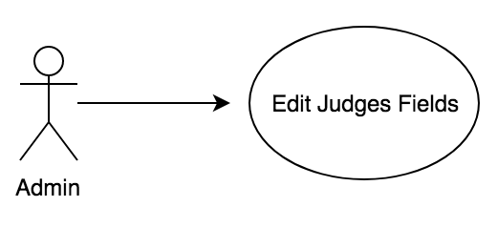

**Sequence Diagram**

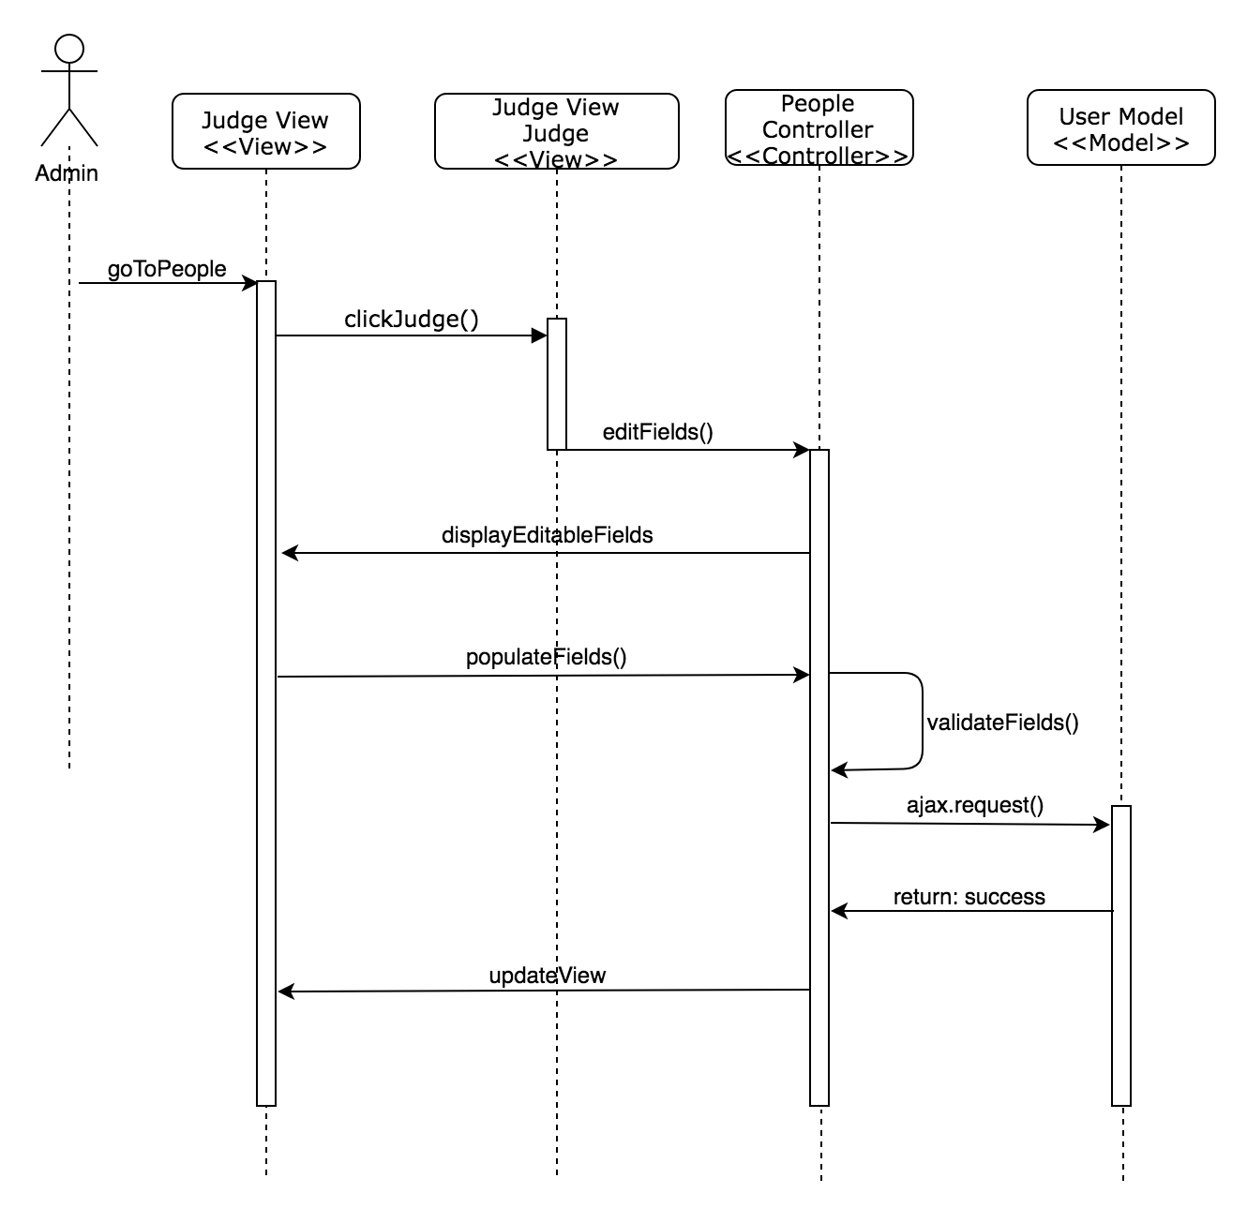

**Class Diagram**

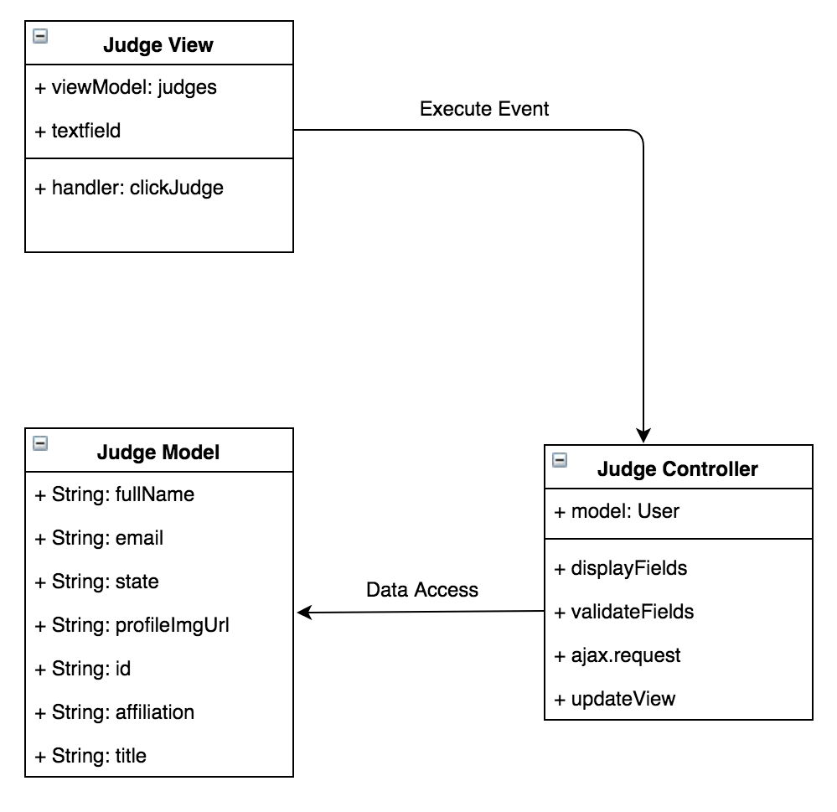

**Unit Test & Integration Test**

**Test case ID:** MJ-648-01

**Description/Summary of Test:** Modifying Judge’s Name Only

**Precondition:** Admin is logged in and currently viewing the judges tab found in people side tab.

**Expected Results:** Judge’s name only gets modified and updated.

**Actual Result:** Judge’s name only got modified and updated.

**Status (Fail/Pass):** Pass

**Test case ID:** MJ-648-02

**Description/Summary of Test:** Modifying Judge’s Email Only

**Precondition:**Admin is logged in and currently viewing the judges tab found in people side tab.

**Expected Results:** Judge’s Email only gets modified and updated.

**Actual Result:** Judge’s Email only got modified and updated.

**Status (Fail/Pass):** Pass

**Test case ID:** MJ-648-03

**Description/Summary of Test:** Modifying Judge’s Title Only

**Precondition:**Admin is logged in and currently viewing the judges tab found in people side tab.

**Expected Results:** Judge’s Project only gets modified and updated.

**Actual Result:** Judge’s Project only got modified and updated.

**Status (Fail/Pass):** Pass

**Test case ID:** MJ-648-04

**Description/Summary of Test:** Modifying Judge’s Organization Only

**Precondition:**Admin is logged in and currently viewing the judges tab found in people side tab.

**Expected Results:** Judge’s Location only gets modified and updated.

**Actual Result:** Judge’s Location only got modified and updated.

**Status (Fail/Pass):** Pass

**Test case ID:** MJ-648-05

**Description/Summary of Test:** Modifying Judge’s State Only

**Precondition:**Admin is logged in and currently viewing the judges tab found in people side tab.

**Expected Results:** Judge’s State only gets modified and updated.

**Actual Result:** Judge’s State only got modified and updated.

**Status (Fail/Pass):** Pass

**Test case ID:** MJ-648-06

**Description/Summary of Test:** Modifying Multiple Judge’s Fields

**Precondition:**Admin is logged in and currently viewing the judges tab found in people side tab.

**Expected Results:** All selected fields get modified and updated.

**Actual Result:** All selected fields got modified and updated.

**Status (Fail/Pass):** Pass

**Test case ID:** MJ-648-07

**Description/Summary of Test:** Cancel modification of Judge’s record

**Precondition:** Admin is logged in and currently viewing the judges tab found in people side tab.

**Expected Results:** Modified fields get reverted back to original information.

**Actual Result:** Modified fields got reverted back to original information.

**Status (Fail/Pass):** Pass

**Test case ID:** MJ-648-08

**Description/Summary of Test:** Inputting invalid Email in Judge’s Email Field

**Precondition:**Admin is logged in and currently viewing the judges tab found in people side tab.

**Expected Results:** Admin gets message saying “This field should be an email address in the format “[user@example.com](mailto:user@example.com)” and does not allow the record to be updated.

**Actual Result:** Admin got message saying “This field should be an email address in the format “[user@example.com](mailto:user@example.com)” and does not allow the record to be updated.

**Status (Fail/Pass):** Pass

**Visual User Guide**

